**Practical 03**

**Boot Sequence**

***Access the BIOS Setting***

1. Navigate to settings. You can get there by clicking the gear icon on the Start menu.

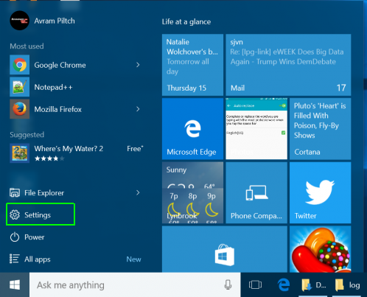

1. click on “Update & Security” at the bottom of the window.

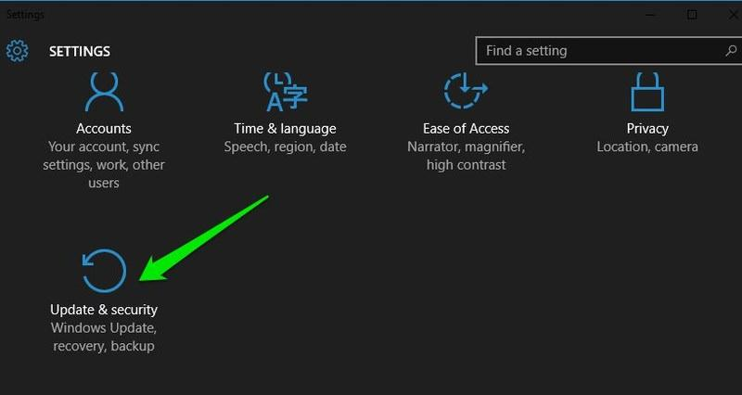

1. Here move to the**“Recovery”** option and click on **“Restart now”** under**“Advanced startup”** option. Your PC will now restart into advanced boot options.

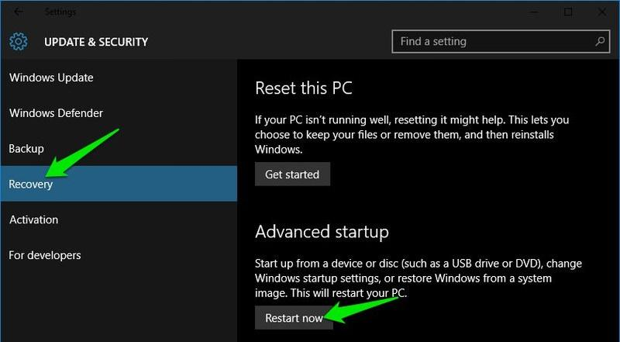

1. **Click Advanced options.**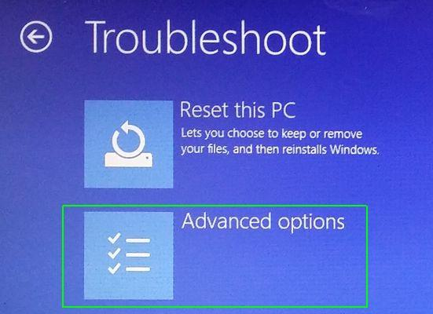
2. **Select UEFI Firmware Settings.**If you don't see this icon, then press Startup Settings, instead. When your PC is restarting, tap F1 (or F2) to access the BIOS.  
   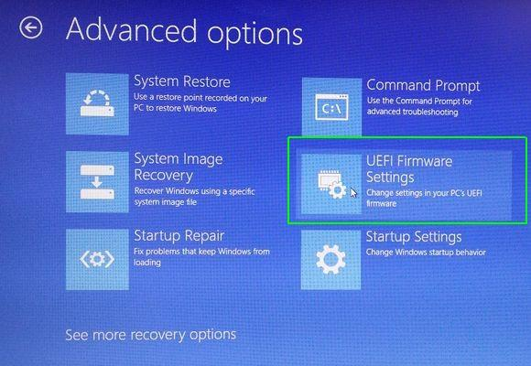

8. **Click Restart.**

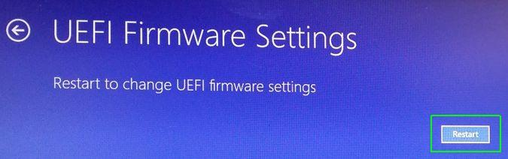

Your system will restart and take you to the BIOS.  
  
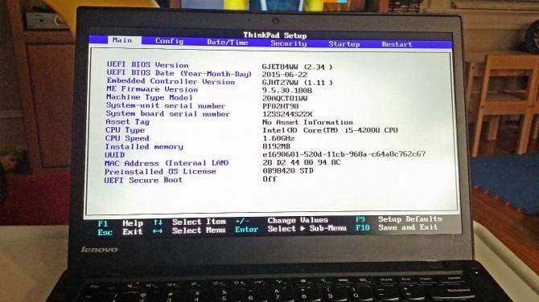

|  |
| --- |
| Windows 10 gives you a lot of options you can configure directly within the operating system, but on every computer, there are some settings you can only change in the BIOS (basic input / output system). The BIOS is the software that is built into your computer's motherboard and controls everything from the boot order of your drives to preboot security options to whether the Fn key on your keyboard activates a function key or a media control.  Unfortunately, because the BIOS is a pre-boot environment, you can't access it directly from within Windows.  Reference: <https://www.laptopmag.com/articles/access-bios-windows-10> |

What are different boot options for your PC? what is BIOS?

|  |
| --- |
|  |

2. What have you learnt?

Today, I have learnt how to access Bios from my laptop. This was also another part of my laptop that I did not understand and know much about. By looking around the class, I noticed despite having the same OS system, Windows, not everyone’s Bios were the same. This meant that the Bios in each computer and laptop will be different for different brands of laptops and computers.

3. Difficulties encountered and how you solved the problems?  
 I had little to no difficulties during this practical as it was relatively simple to access the BIOs on my windows OS laptop.

*End of Practical*